Food4All - An App for Food Waste Reduction

1. Introduction
Food waste is a critical issue globally, not just for its environmental impact, but also because of its economic and social implications.
According to data issued in December 2023 by the nonprofit ReFED, 38% of the 235M tons of food produced in 2022 in the United States became surplus food. Surplus food is
food unsold or not eaten. From this, 77.6M tons of food were food waste. At the same time, according to USDA Economic Research Service, 44.2 million people lived in food-insecure households in the United States, and an additional 11.7 million adults lived in households with very low food security in the same year.

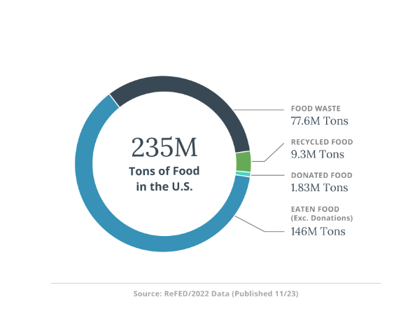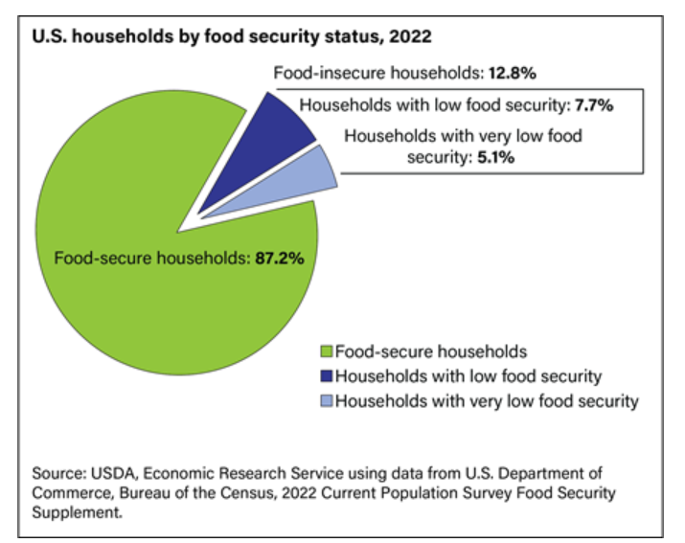

Such a stark paradox intrigued me, and I felt compelled to step into action and bring my contributions to alleviating this complex and consequential issue. I founded Scholars4Impact, a nonprofit that empowers high school students to engage in volunteering activities, such as facilitating surplus food donations from restaurants to food banks. To scale impact, I developed Food4All, an app prototype that connects restaurants with food banks: restaurants upload real-time information on food inventory, classified in perishable and non-perishable, and the app matches it with food banks based on location and demand. The app removes the communication barriers between supply and demand and accelerates the pace of donations.

That’s how Food4All was born.

2. App Description (with data flow diagrams)
Food4All is a versatile app developed using Figma that seamlessly connects restaurants with food surplus with entities in need of food deliveries, such as food banks, donation centers and other nonprofit entities.

The app has the capability of collecting multitude data elements, such as food surplus and demand by product, location, quantity, and type (perishable, non-perishable).

The app is in the prototype phase, and upon more feedback and validation from both food distributors and food providers, I plan to build the backend connectivity and to make it available using Google Play Store.

The diagram below describes the key structural elements of the app.

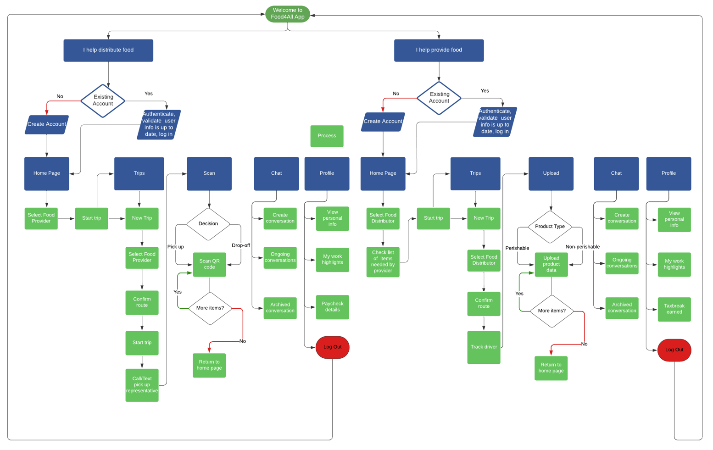

3. App Frames
3.1 Food Distributor Frames

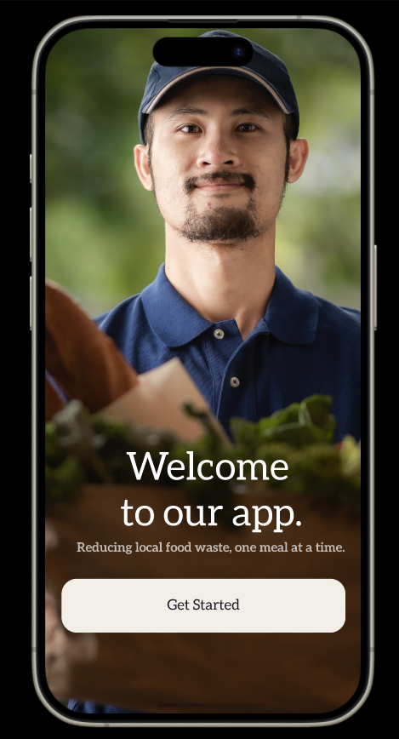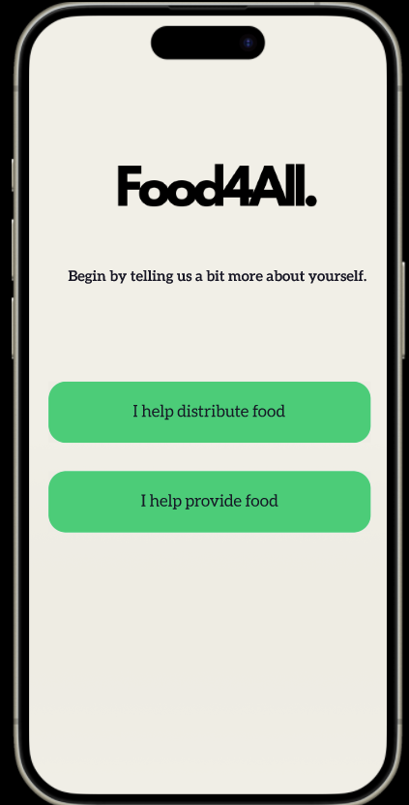

Frame 1: welcome to Food4All App Frame 2: food distributor menu
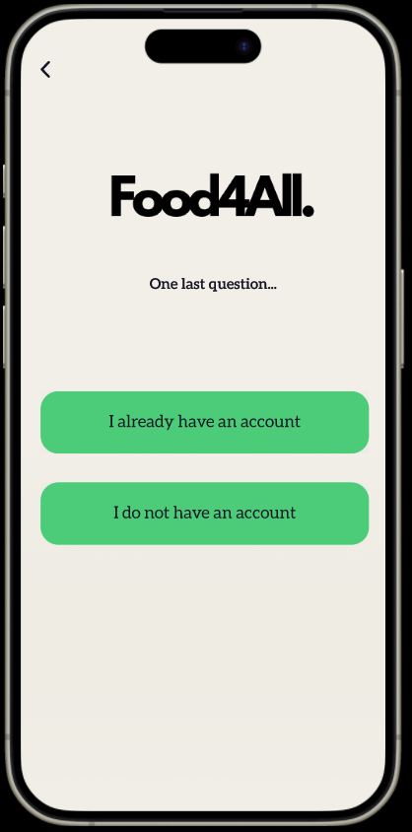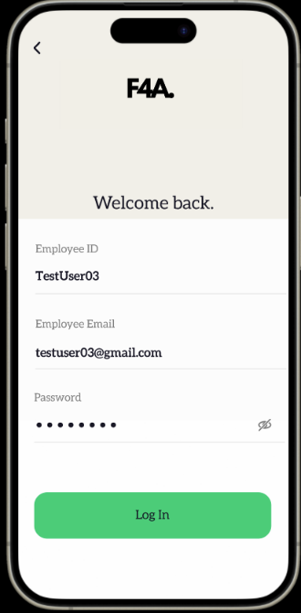
Frame 3: old/new account Frame 4: log in
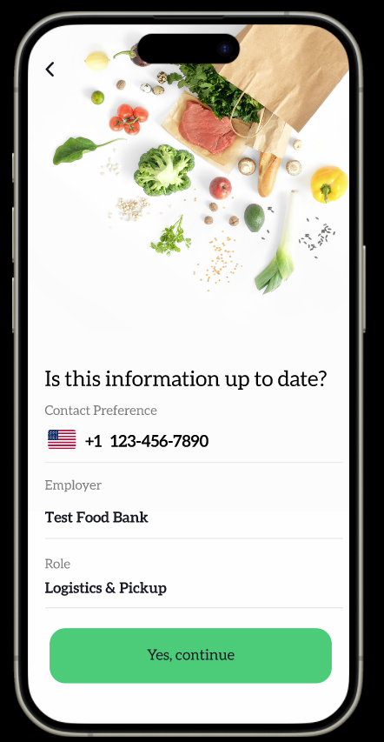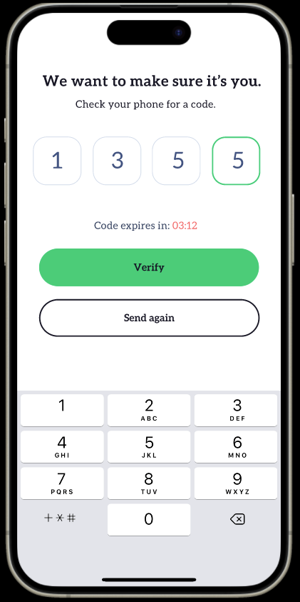
Frame 5: validate personal info Frame 6: security validation
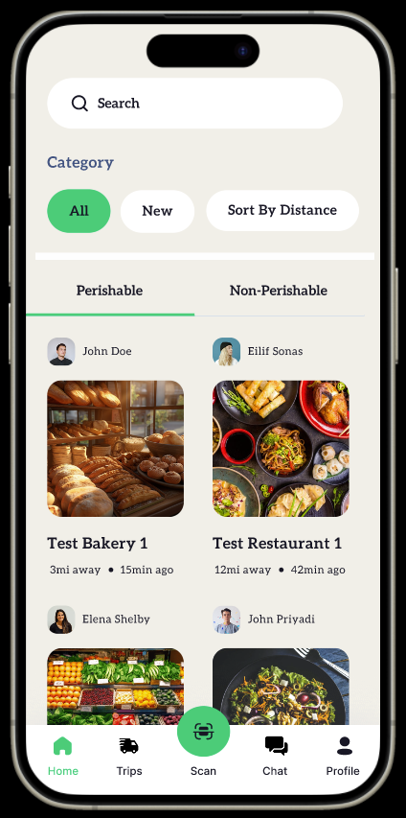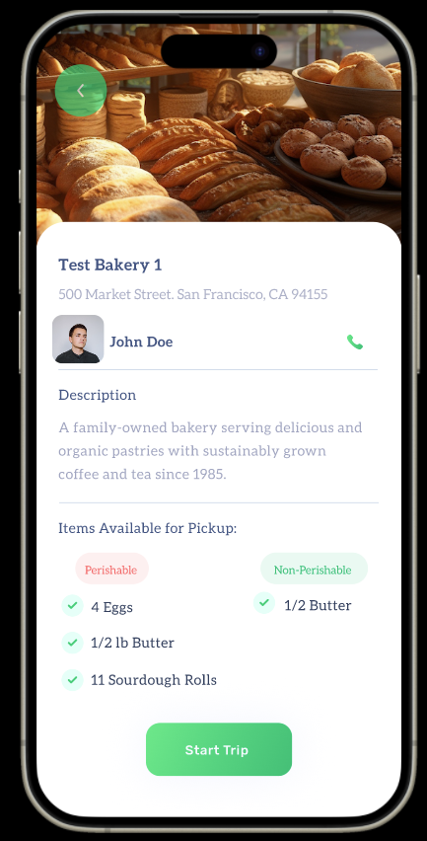
Frame 7: food categories by restaurant Frame 8: description of restaurant and the surplus food available

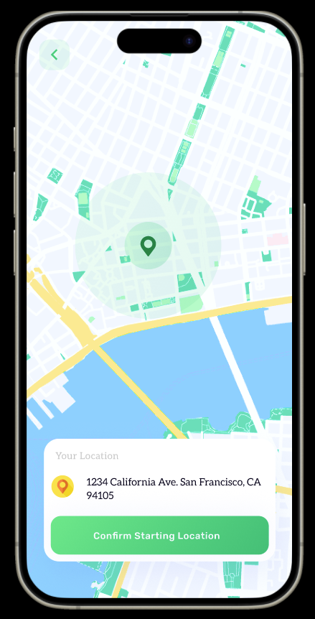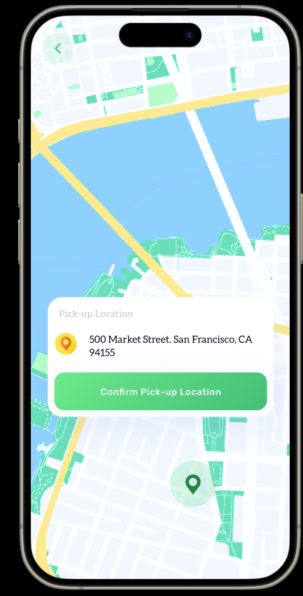
Frame 9: route starting point Frame 10: route pick up location

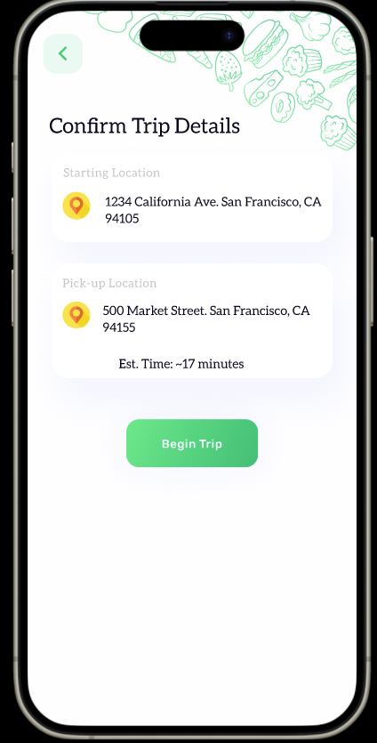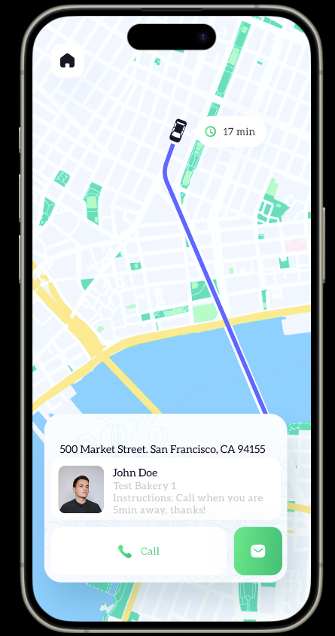

Frame 11: trip details Frame 12: real time driving tracking

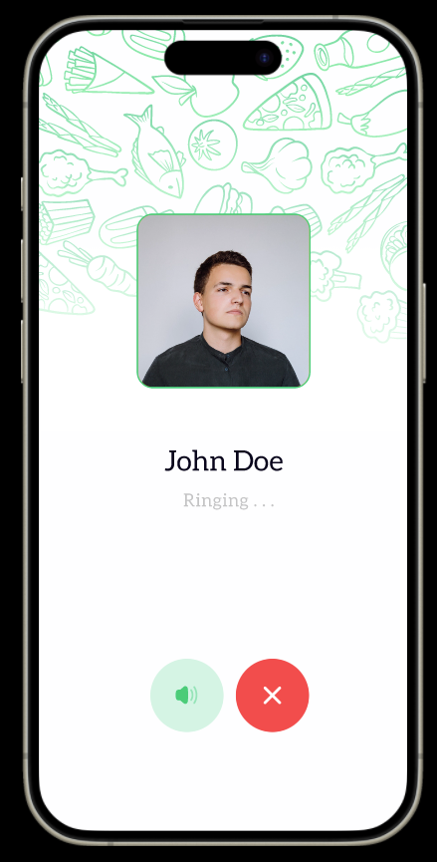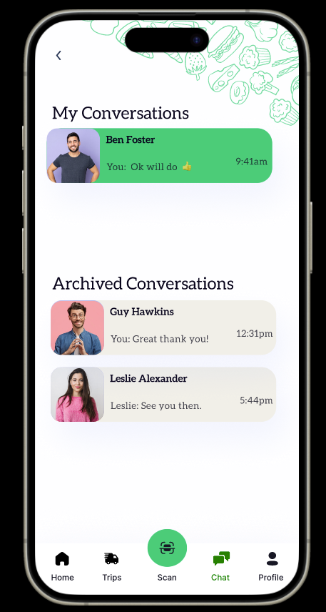
Frame 13: driver calling the restaurant Frame 14: log of conversations

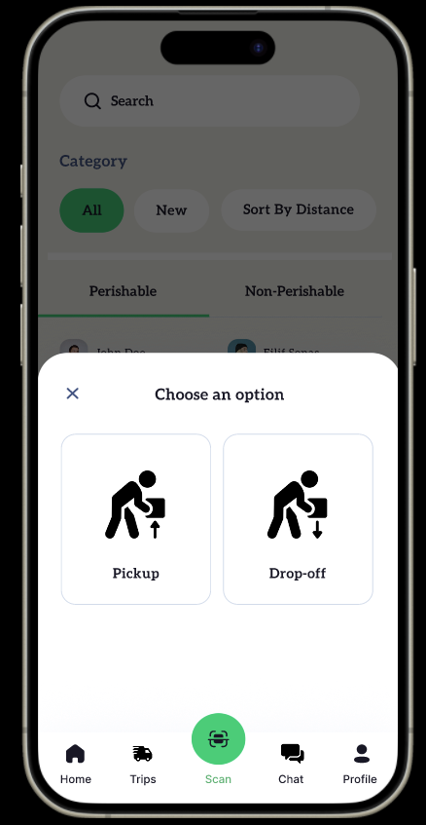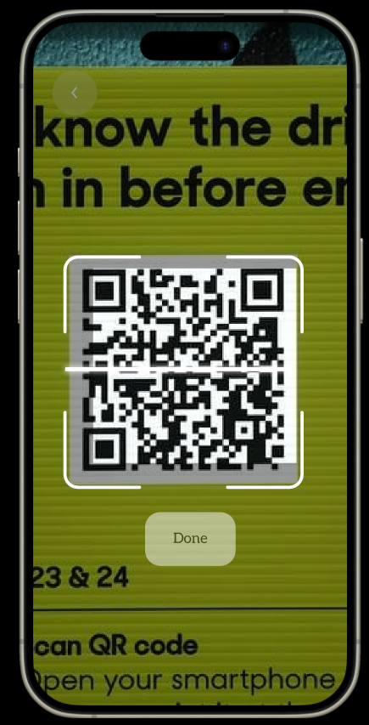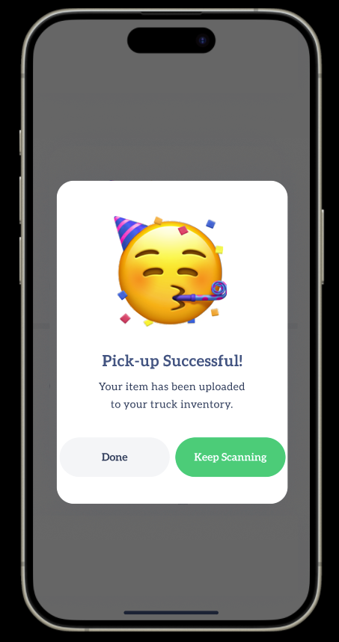
Frame 15: pickup menu Frame 16: pickup QR Frame 17: pickup confirmation

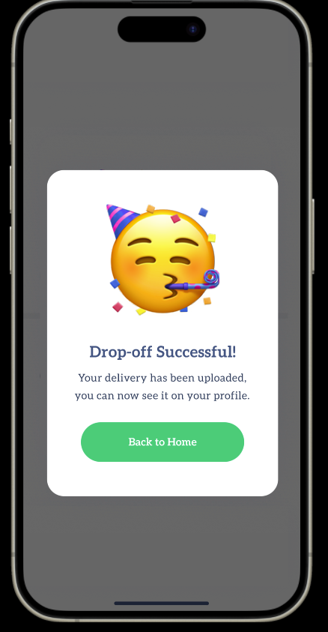
Frame 18: drop-off menu Frame 19: drop-off QR Frame 20: drop-off confirmation

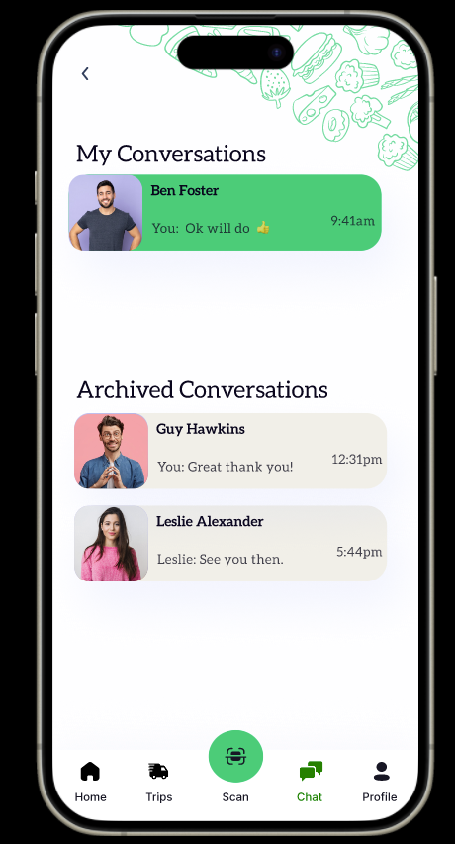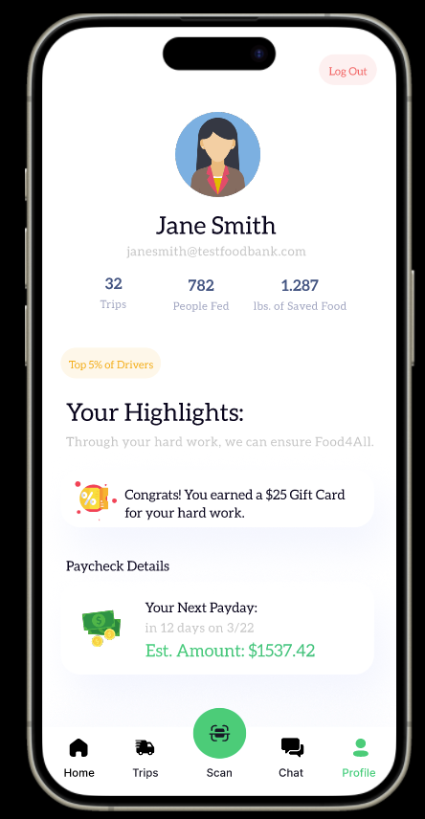

Frame 21: log of conversations Frame 22: tracker of trips and impact

3.2 Food Provider Frames

Frame 23: food provider menu Frame 24: old/new account

Frame 25-27: log in, validation of personal data, security validation
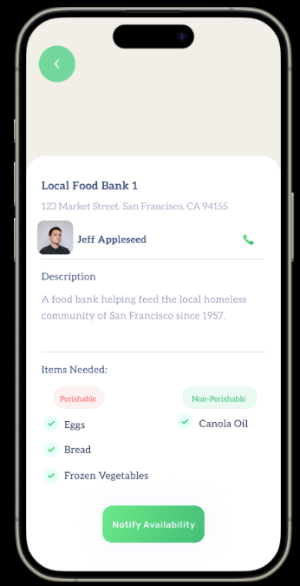
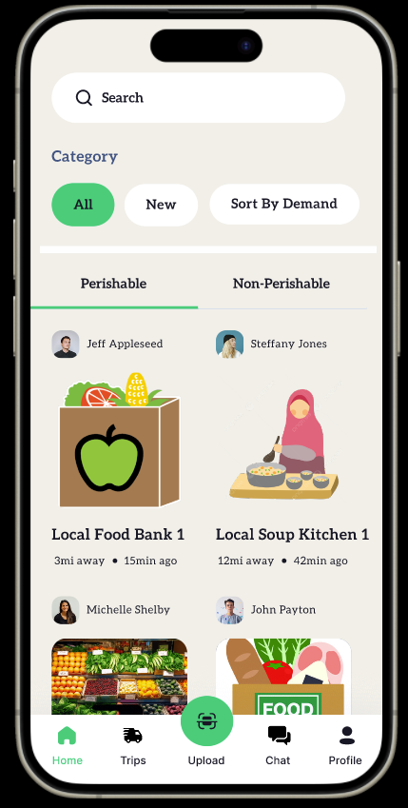
Frame 28-29: checking food banks in need of food, by type of food (perishable/nonperishable)

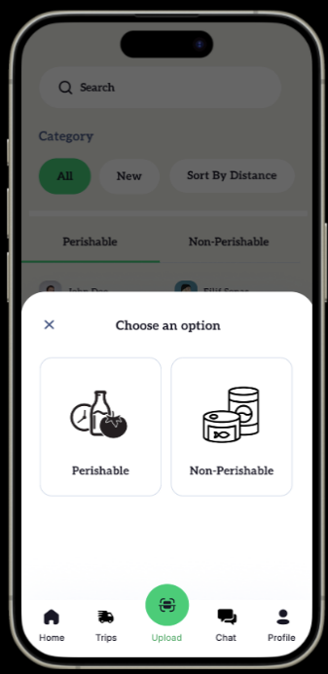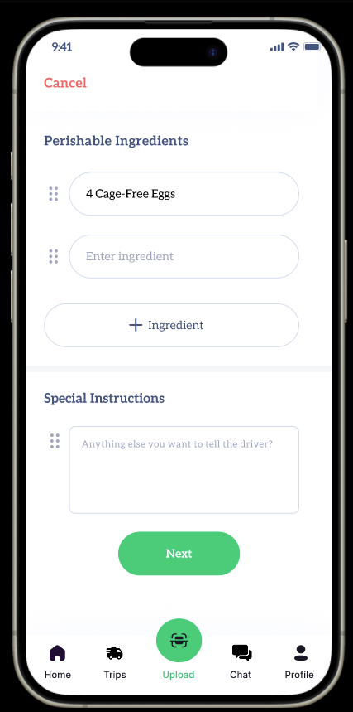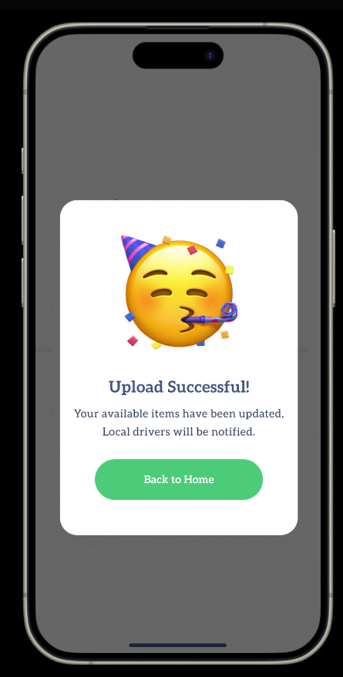

Frame 30-33: upload of data of perishable surplus food

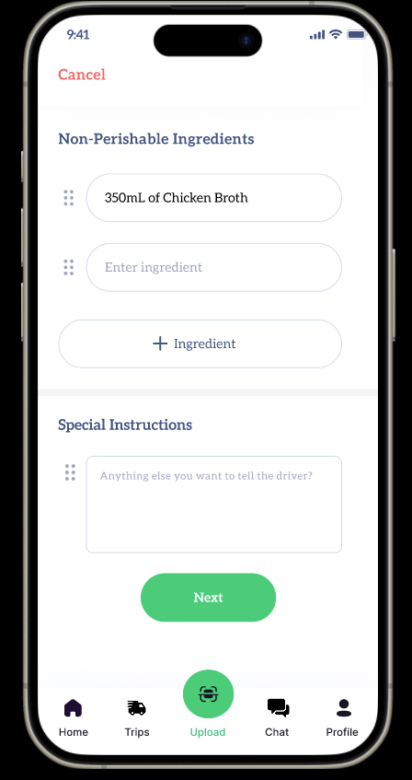
Frame 34-36: upload of data of non-perishable surplus food
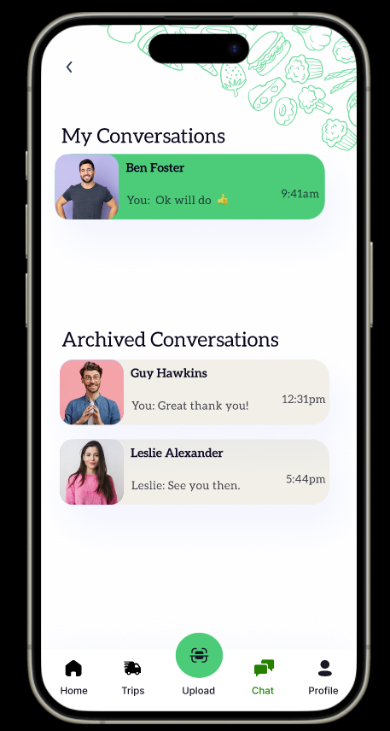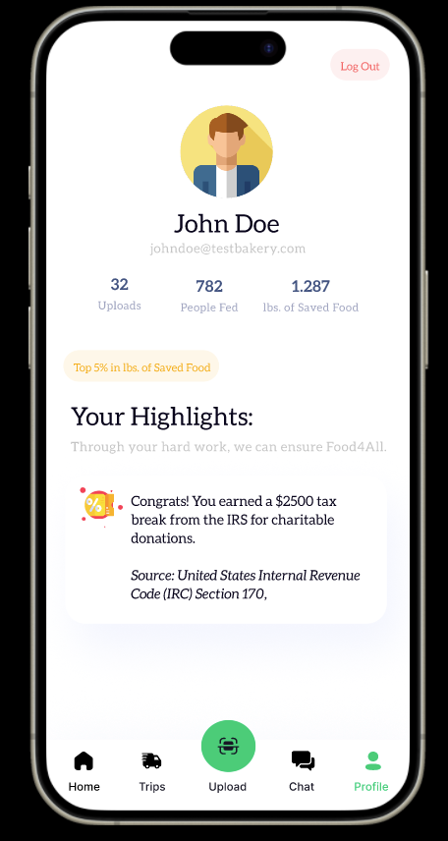
Frame 37-38: data upload successful; count of food donations impact and related tax break

